# **DEFECT SUMMARY REPORT**

**Tested Application** – Buggy Cars Rating

**Document Version** – 1.0

**Defect # 1:**

**Description:** When a new user completes the ‘registration’ process successfully and performs the ‘log-In’ process in the same instance; the ‘registration’ doesn’t disappear and home page doesn’t get shown.

**Steps To Reproduce:**

1. Launch the Buggy Cars Rating application
2. Click the ‘Register’ button
3. Fill in the ‘Register with Buggy Cars Rating’ section by providing inputs in Login, First Name, Last Name, Password and Confirm Password fields
4. Click the ‘Register’ button
5. Observe the message as ‘Registration is successful’
6. Fill in the Log-In section by providing inputs in Login and Password fields
7. Click the ‘Login’ button

**Expected Result:**

After the user performs the login; the registration page should disappear and the home page should get displayed.

**Actual Result**:

The ‘Registration’ section should disappear post Login but here the ‘Registration’ page remains even after the user performs log-in is successfully i.e. the page is not getting refreshed due to session is getting held.

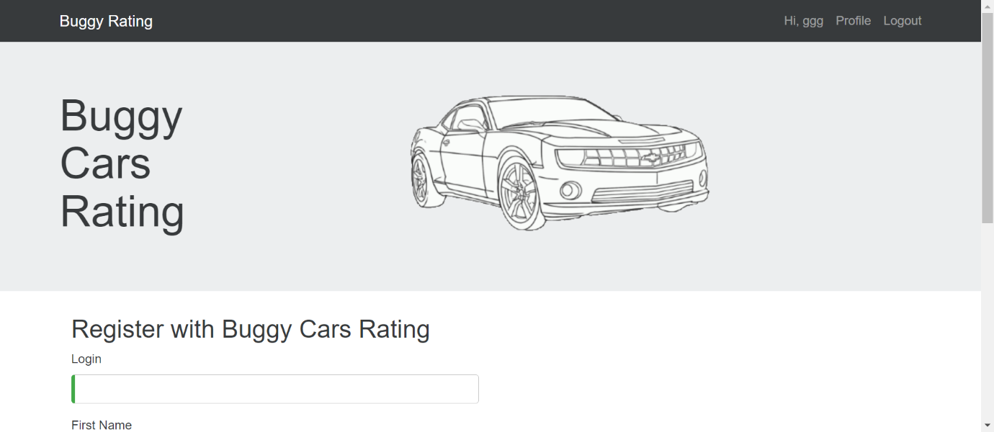

**Defect # 2:**

**Description:** When the user tries to navigate to Home Page by clicking the “Buggy Rating” at the left right corner from the ‘Popular Make’ section; it doesn’t get navigated to the Home Page as the link looks broken

**Steps To Reproduce:**

1. Launch the Buggy Cars Rating application
2. Click the ‘Popular Make’ image/icon
3. Try to navigate to the Home Page by clicking the ‘Buggy Rating’ link
4. Observe the occurrence

**Expected Result:**

Home page should get navigated when the user clicks the ‘Buggy Rating’ link.

**Actual Result**:

The ‘Buggy Rating’ link becomes unresponsive and Home Page is not getting navigated.

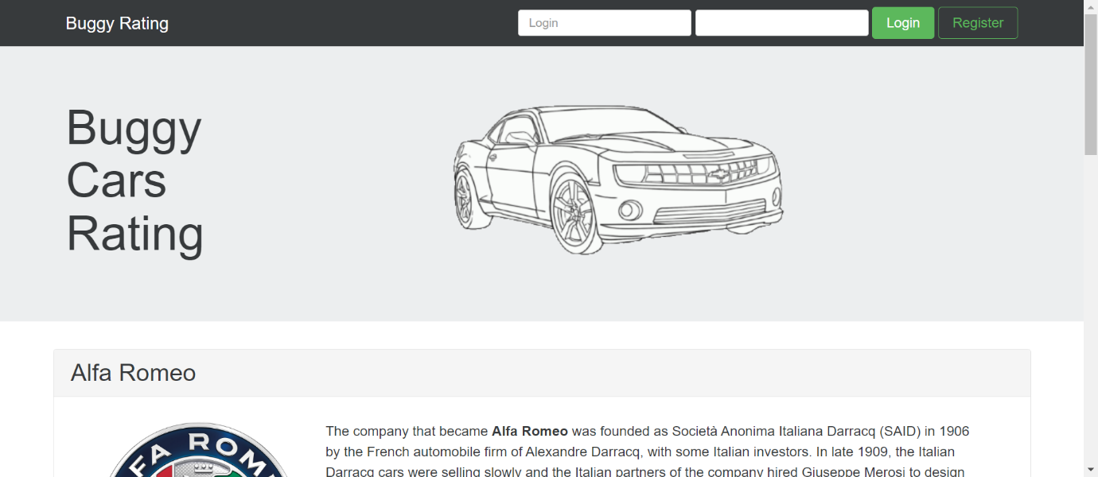

Continued.

**Defect # 3:**

**Description:** When the User sorts the vehicle engine by capacity in the overall rating page; the vehicle image for the Lancia Ypsilon shows broken.

**Steps To Reproduce:**

1. Launch the Buggy Cars Rating application
2. Click the ‘Overall Rating’ image/icon
3. Perform the Sorting by clicking the ‘Engine’ link
4. Observe the vehicle image for the Lancia Ypsilon which shows broken

**Expected Result:**

Vehicle image should get displayed correctly after the user performs sorting by engine capacity.

**Actual Result**:

The vehicle image for the Lancia Ypsilon is getting displayed broken after the user performs sorting by engine capacity.

